1)What is the Random Forest Algorithm?
2)What is Variance and Bias tradeoff?
3)What is out of bag evaluation?
4)How is a Random Forest related to Decision Trees?
5)What are the advantage of RF?
6)How randomforest handle missing values?
7)How is it possible to perform Unsupervised Learning with Random Forest?
8)What does random refer in randomforest?
9)Why is the training efficiency of Random Forest better than Bagging?
10)What is entropy?

1)Random Forest is an ensemble machine learning algorithm that follows the bagging technique. The base estimators in the random forest are decision trees. Random forest randomly selects a set of features that are used to decide the best split at each node of the decision tree.
Looking at it step-by-step, this is what a random forest model does:
1. Random subsets are created from the original dataset (bootstrapping).
2. At each node in the decision tree, only a random set of features are considered to decide the best split.
3. A decision tree model is fitted on each of the subsets.
4. The final prediction is calculated by averaging the predictions from all decision trees.
To sum up, the Random forest randomly selects data points and features and builds multiple trees (Forest).
Random Forest is used for feature importance selection. The attribute (.feature_importances_) is used to find feature importance.
Some Important Parameters:-
1. n_estimators:- It defines the number of decision trees to be created in a random forest.
2. criterion:- "Gini" or "Entropy."
3. min_samples_split:- Used to define the minimum number of samples required in a leaf node before a split is attempted
4. max_features: -It defines the maximum number of features allowed for the split in each decision tree.
5. n_jobs:- The number of jobs to run in parallel for both fit and predict. Always keep (-1) to use all the cores for parallel processing.

2)In predicting models, the prediction error is composed of two different errors
1. Bias
2. Variance
It is important to understand the variance and bias trade-off which tells about to minimize the Bias and Variance in the prediction and avoids overfitting & under fitting of the model.
Bias: It is the difference between the expected or average prediction of the model and the correct value which we are trying to predict. Imagine if we are trying to build more than one model by collecting different data sets, and later on, evaluating the prediction, we may end up by different prediction for all the models. So, bias is something which measures how far these model prediction from the correct prediction. It always leads to a high error in training and test data.
Variance: Variability of a model prediction for a given data point. We can build the model multiple times, so the variance is how much the predictions for a given point vary between different realizations of the model.
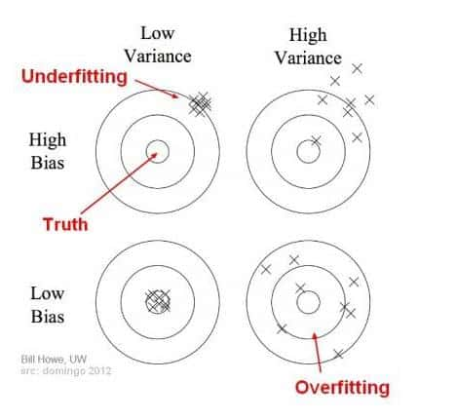
For example: Voting Republican - 13 Voting Democratic - 16 Non-Respondent - 21 Total - 50 The probability of voting Republican is 13/(13+16), or 44.8%. We put out our press release that the Democrats are going to win by over 10 points; but, when the election comes around, it turns out they lose by 10 points. That certainly reflects poorly on us. Where did we go wrong in our model?
Bias scenario's: using a phone book to select participants in our survey is one of our sources of bias. By only surveying certain classes of people, it skews the results in a way that will be consistent if we repeated the entire model building exercise. Similarly, not following up with respondents is another source of bias, as it consistently changes the mixture of responses we get. On our bulls-eye diagram,these move us away from the center of the target, but they would not result in an increased scatter of estimates.
Variance scenarios: the small sample size is a source of variance. If we increased our sample size, the results would be more consistent each time we repeated the survey and prediction. The results still might be highly inaccurate due to our large sources of bias, but the variance of predictions will be reduced
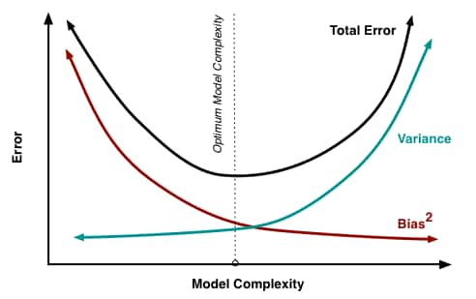

3)In supervised learning algorithm Decision Trees, we make decisions and predict the values using an if-else conditions like trees in different branches. But problem with this method is high depth od D-Trees tends to overfitting the training data hence lead to High Variance. So we used ensemble technique like Random Forest with out of bag score/evaluation method. In Random forest we create multitude of independent decision trees (using bootstrapping ie randomly selecting training data points) at training time and outputting majority prediction from all the trees as the final output. While selecting random data points from the mail training set we left some sample, which is known as out-of-bag sample. So these samples not used while creating D-trees in Random forest;
OOB_score is the number of correctly predicted rows and OOB error is the no of wrongly classified rows from the out-of-bag sample.
OOB evaluation prevent data leakage hence reduce high variance and give better predictive model with less computations. But for high volume of data, it takes lot of time and computations.

4)Random forest is an ensemble learning method that works by constructing a multitude of decision trees. A random forest can be constructed for both classification and regression tasks.
- Random forest outperforms decision trees, and it also does not have the habit of overfitting the data as decision trees do.
- A decision tree trained on a specific dataset will become very deep and cause overfitting. To create a random forest, decision trees can be trained on different subsets of the training dataset, and then the different decision trees can be averaged with the goal of decreasing the variance.
5)Random Forest is very versatile and can be used in both regression and classification tasks. It can also handle all binary, categorical, and numerical features.
- The process is parallelizable where the process can be split to run in different machines.
- It performs better in high dimensionality since the work is on subsets of data.
- The training speed is faster than decision trees because they are working only on a subset of features. Even if there are hundreds of features the training speed will be significantly faster.
- The Random Forest is good at balancing errors for class population unbalanced data sets.
- It has low bias, but moderate variance because when all the trees are averaged in random forest, all the variances are also averaged so it has low bias but a moderate variance.
6)The Random Forest methods encourage two ways of handling missing values:
- Drop data points with missing values. This is not recommended due to the fact that all the available data points is not used.
- Fill in the missing values with the median (for numerical values) or mode (for categorical values). This method will brush too broad a stroke for datasets with many gaps and significant structure.
There are other methods of filling in missing values such as calculating the similarity between the missing features, and the missing values estimated by weighting.

7)As part of their construction, random forest predictors naturally lead to a dissimilarity measure among the observations. One can also define a random forest dissimilarity measure between unlabeled data:
The idea is to construct a random forest predictor that distinguishes the observed data from suitably generated synthetic data.
Many unsupervised learning methods require the inclusion of an input dissimilarity measure among the observations. Hence, if a dissimilarity matrix can be produced using Random Forest, unsupervised learning can be successfully implemented. The patterns found in the process will be used to make clusters.

8)Random forest is an extension of the bagging method as it utilizes both bagging and feature randomness to create an uncorrelated forest of decision trees. Hence, random forest is Random in the following ways:
- Each tree is trained on a random subset of features, which ensures low correlation among decision trees.
- Each tree in the forest is trained in 2/3-rd of the total training data and data points are drawn at random from the original dataset.

9)The difference between Random Forest and Bagging is the fact that for Random Forest only a subset of features out of all are selected in random and the best split feature from the subset is used to split each node in a tree.
In bagging all the features are considered in splitting the node.
Due to the fact that bagging considers all the features, the training efficiency of random forest is better.

10)The basic definition of entropy is a measure of disorder. The equation of entropy is as follows:
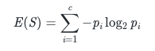
​
p_{i}is the probability of frequentist probability of the element i in the data.
In machine learning models, the goal is to decrease uncertainties. Thus, the models should have less entropy.
The reduction of entropy is defined as information gain. It is shown below:
IG(Y,X)=E(Y)−E(Y∣X)
IG(Y,X)=E(Y)−E(Y∣X)
- Information gain is just the subtraction of entropy of Y given X from the entropy of just Y. E(Y|X) corresponds to the information of Y that we already know. So, E(Y|X) is not new information for the model.

